Solution Architecture
Date | 30 September 2026
Team ID | SWTID-2026-3379
Project Name | AI Weather Wise
Team Size | 4
Team Leader | PREETHI L
Team Members | DEVI PRIYA S, SUMITHRA G, SIPORAL U
Maximum Marks | 5 Marks

Solution Architecture Diagram
AI Weather Wise follows a layered architecture: a presentation layer (frontend), an application layer (backend / API layer, weather data processing and guidance logic), and an external data source (Weather API). The diagram shows the flow of a single user request from the user to the output and back.
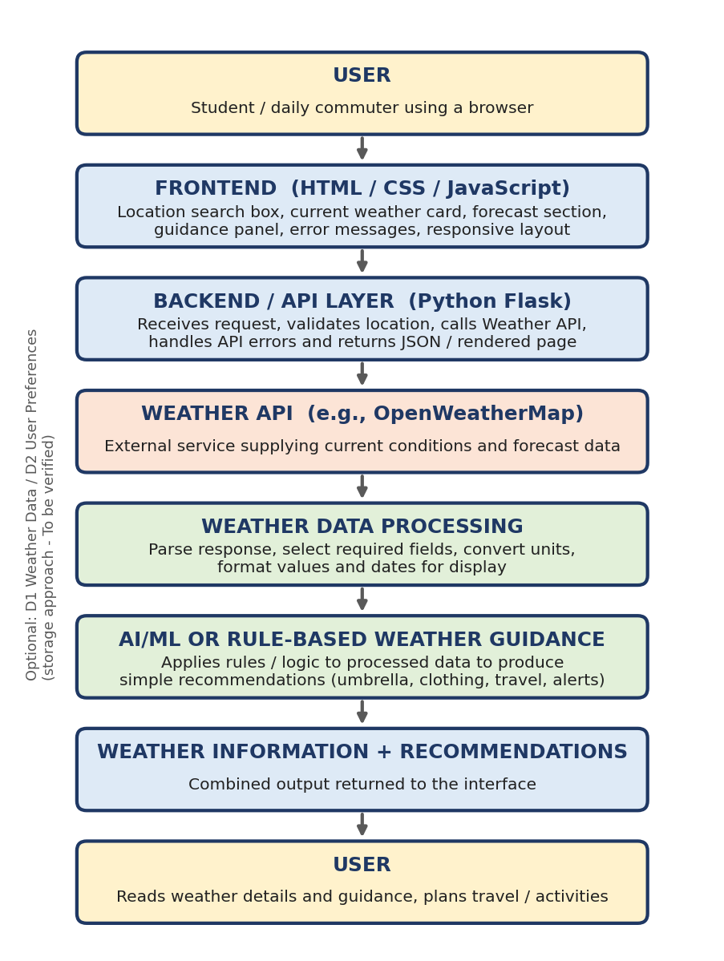
Figure 1: Conceptual solution architecture of AI Weather Wise

Component Description Table
Component Name | Description / Role in Architecture | Technologies Used
Presentation Layer (Frontend) | Provides the search box, current weather card, forecast section, guidance panel and error messages. Sends the location request to the backend and displays the response. Layout adapts to phone and desktop. | HTML, CSS, JavaScript (To be verified)
Backend / API Layer | Receives requests from the frontend, validates the location, calls the Weather API, handles errors and returns the result. Keeps the API key on the server side. | Python Flask (To be verified)
Weather API Integration | Sends an HTTP request with location and API key and receives current weather and forecast data as JSON. | OpenWeatherMap or similar Weather API; requests library (To be verified)
Weather Data Processing | Parses the JSON response, selects required fields (temperature, condition, humidity, wind, rain chance), converts units and formats dates and values for display. | Python (To be verified)
AI/ML or Rule-Based Guidance Layer | Applies defined rules or logic to the processed data to produce plain-language recommendations such as umbrella, clothing, travel and caution messages. A trained ML model is not claimed. | Python rule-based logic (To be verified)
Data / Storage (optional) | Temporary storage of the latest weather data (D1) and simple user preferences (D2) if implemented. | To be verified
Configuration & Security | Stores the API key in an environment / configuration file excluded from GitHub; validates user input. | .env file, .gitignore (To be verified)

Request Flow
- The user opens the application and enters a location.
- The frontend checks that the input is not empty and sends the location to the backend.
- The backend / API layer validates the request and calls the Weather API using the configured API key.
- The Weather API returns weather data (or an error such as 'city not found').
- The weather data processing step extracts the fields needed and converts them into display-ready values.
- The AI/ML or rule-based guidance layer analyses the processed data and creates recommendations.
- The backend returns weather information and recommendations to the frontend.
- The frontend displays current weather, forecast and guidance, or a friendly error message, to the user.

Error Handling Paths
Situation | Where Detected | Expected Behaviour
Empty location input | Frontend / Backend | Message asking the user to enter a location; no API call is made.
Location not found | Weather API response | Message that the location was not found and a suggestion to check the spelling.
API key invalid or rate limit reached | Weather API response | Generic 'service unavailable' message for the user; details logged for developers.
Network problem or timeout | Backend | Message that weather data could not be retrieved; user may retry.

Design Decisions
- Frontend / backend separation - the frontend only handles display and input; the backend handles API calls, processing and secrets.
- Rule-based guidance first - transparent rules are easier to test and explain than a model with no training data; ML is left as future scope.
- Modular processing - fetching, processing and guidance are separate steps so each can be improved or tested independently.
- Scalability - the layers can later be deployed to the cloud, and further weather data sources can be added behind the API layer.

Note: All technology names in this architecture are the planned / proposed stack from the project brief and are To be verified against the team's actual code.

